Daniel Valverde &  
Duncan Ferguson  
Comp 4441  
5/15/2021

**Project Proposal**

**Research question.**

The Glen Canyon Dam is the second largest Dam in the United States, the largest being the Hoover Dam. Both of the Dams restrict the flow of the Colorado River and are considered critical infrastructure. The Glen Canyon Dam alone produces around 5 billion kWh of hydroelectric power that is distributed to Wyoming, Utah, Colorado, New Mexico, Arizona, Nevada, and Nebraska.

Lake Powell is the reservoir that sits above the Dam. It provides water for the majority of the South Western United States. Currently, the reservoir is only 34.62% full. Some scientists believe that the lake will never fill again. The dropping water level comes with some serious consequences. As of May 10th 2021 the lake’s elevation is 3561.13 ft. If that level drops to 3490ft the dam is at risk of losing its power generation capabilities. Furthermore if the lake reaches 3374ft, it loses its ability to release water downriver, meaning that the Colorado would cease flowing as we know it. 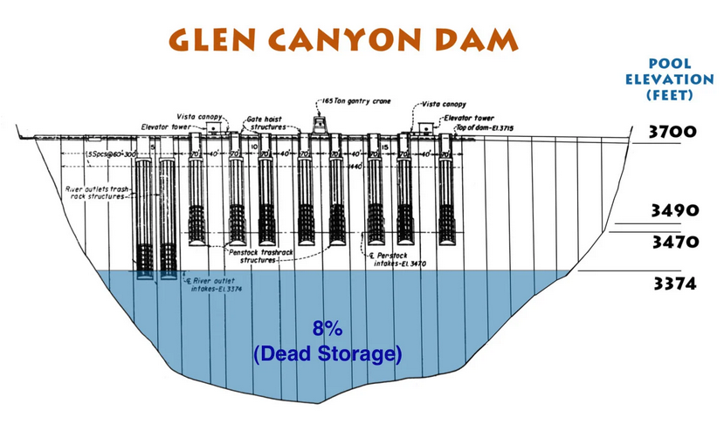

**Our project is therefore to determine the rate of decline of the lake. Will the Lake lose power generation? And if so, when will that happen?** While on it’s face this seems like an easy question there are many different variables. As Projected Water Demand increases and Lake Elevation decreases one can deduce the significance of studying this topic.

**Statistical or analytical methods**

Water inflow, and water release are major data point’s that help determine the elevation of Lake Powell. The statistical and analytical methods that we would like to use to analyze our question are correlation and regression models between water inflow, outflows and lake elevation.

By looking at these correlations and using regression models we will be able to determine if the lake is declining purely due to the drought and less inflows, or if it is decreasing because the government is releasing more water than what is flowing into the dam to meet contracts.

The method not covered in class that we will use as part of our analysis is the Pearson’s R tests to help determine the correlation between our variables. How are the inflows and elevation related and how are the elevation of the lake and outflows related and how inflows and outflows are related.

ANOVA test will be used to help determine if there are significant relationships between the inflow, outflow, and elevation level. Regression models will then help us determine if we can then predict when the Lake will run out of power generation. These models will also help us make suggestions to the lake’s outflowing levels.

**Variables in the Data**

The main independent variables are inflows over time. The lake elevation is dependent upon inflows and outflows. We are exploring whether or not the outflows are independent or dependent. The theory is that the lake elevation and outflows are directly correlated to the inflows. We will be able to draw conclusions on this theory once we have created the Pearson’s R test.

Thankfully the U.S. government through the Bureau of Reclamation has been keeping track of all of the data diligently. It is time series data on inflows and outflows in CFS (Cubic Feet per Second). The lake’s water capacity is measured in elevation above sea level in time series.

Our theory is that the outflows are dependent upon government contracts, when they should be dependent upon lake inflows. The disconnect here is why the lake’s levels are dropping. The Outflow contract’s do not take into account the inflows leading to the lake outflowing more than the inflows.

Data Sources:

https://www.usbr.gov/uc/water/hydrodata/